Date:
September 11, 2024

Attn:
Nick Heinzman
Ideal Construction
19019 Evans St
Elkhorn, NE 68022
Subject:
Ralston Apartment Renovations
5617 S 77th Street
Ralston, NE 68127

Dear Nick:

Ralston Apartment Renovations
5617 S 77th St Ralston, NE 68127

Existing Building Improvements and interior renovations

Project Overview for Proposers.

The space at 5617 S 77th St will be rehabilitated and renovated into a multi-tenant mixed use space featuring (2) retail units and (6) sleeping units. Scope of work includes exterior modifications as required for rehabilitation of the existing space, access to the second-floor sleeping units with a new deck, site improvements for community use and exterior envelope modifications.
Interior work includes framing with finishes, full mechanical/electrical/plumbing redesign as required for the new units. Retail spaces are provided as white box spaces tenant-ready.

Issued Documents:
- Drawings
- Bid Form for GC/CM Proposal Breakdown (See Attachment)
- General Conditions Contractor Proposal (See Attachment)

Project Timelines:
GC/CM bid date for all Subs & Vendors is September 26, 2024
GC/CM Bid Submission to Owner October 1, 2024.
GC/CM Award anticipated no later than October 3, 2024.

Proposal Deliverables
- Bid form filled out in its entirety.
- Outline schedule for project of major activities.
- Direct Construction Cost(s) by scope of work ie.. (HVAC, Plumbing, Electrical, Framing, Drywall, ATC, Drs & Hardware, Flooring, etc.) and intended subcontractor or vendor for each scope of work.
- Separate Project Clarifications Document, if any.
- Separate Project Exclusions Document, if any.
Contract:
The AIA 101 contract will be entered between the Owner and the Contractor for the project.

Enclosures:
PDF Files of Issued Documents Section Identified above.

Respectfully,

Sincerely,
Slate Architecture
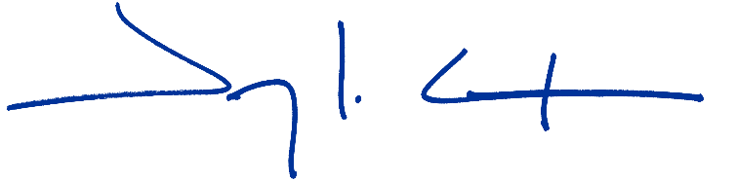

Jeremy L. Carlson, AIA, NCARB
Registered Architect | Principal
Slate Architecture
3624 Farnam Street
Omaha, Nebraska 68131

